**PRACTICAL NO.10**

**Advance GIS Operations 2: Batch Processing using Processing Framework**

**Automating Complex Workflows using Processing Modeler**

**Automating Map Creation with Print Composer Atlas**

**Batch Processing using Processing Framework:**

Vector > Geoprocessing Tools.. > Clip.. >

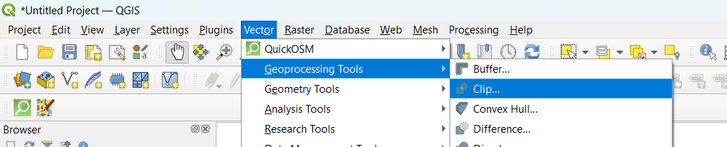

At clip > Click the “Run as batch process” button >

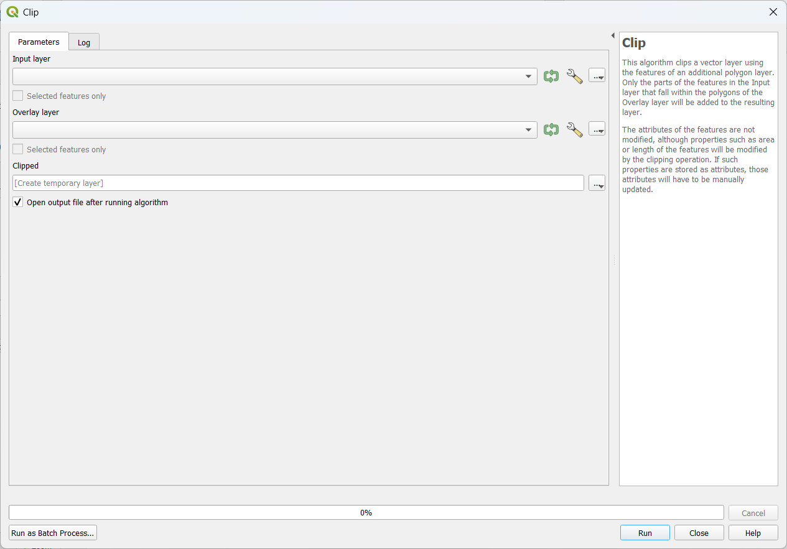

At Batch Processing : Add Input layer:ne_10m_rivers_lake_centerlines.zip ,Overlay layer : IND_adm.zip and Clipped : clippedne_10m_rivers_lake_centerlines.gpkg > Autofill mode : Fill with parameter values and Parameter to use : Input layer > Ok >

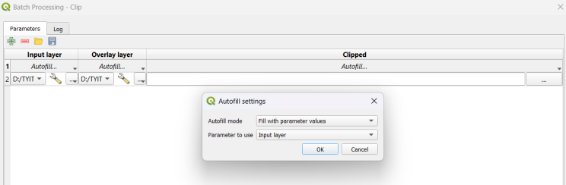

Add another row > Add Input layer:ne_10m_populated_places_simple.zip ,Overlay layer : IND_adm.zip and Clipped : clippedne_10m_populated_places_simple.gpkg > Autofill mode : Fill with parameter values and Parameter to use : Input layer > Ok >

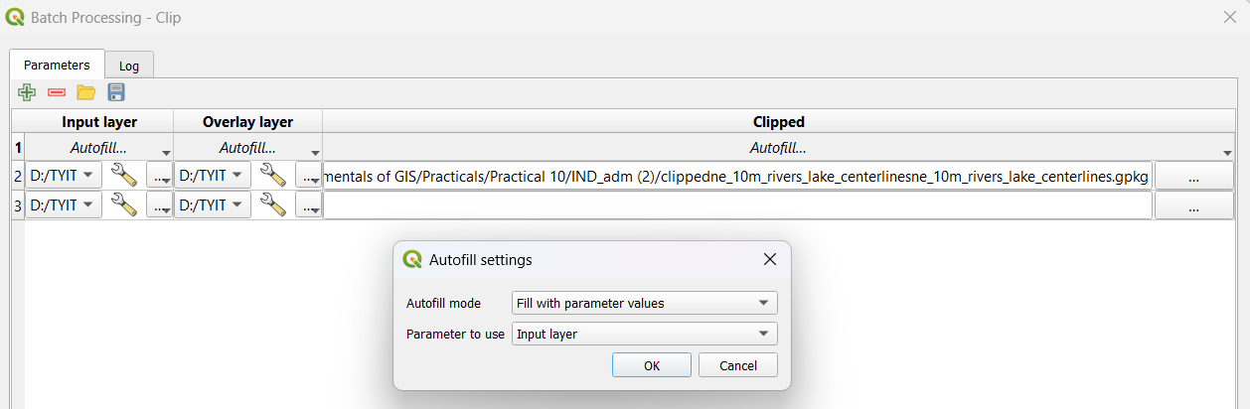

After Adding two rows > Click at Checkbox of “Load Layers on completion” > Run >

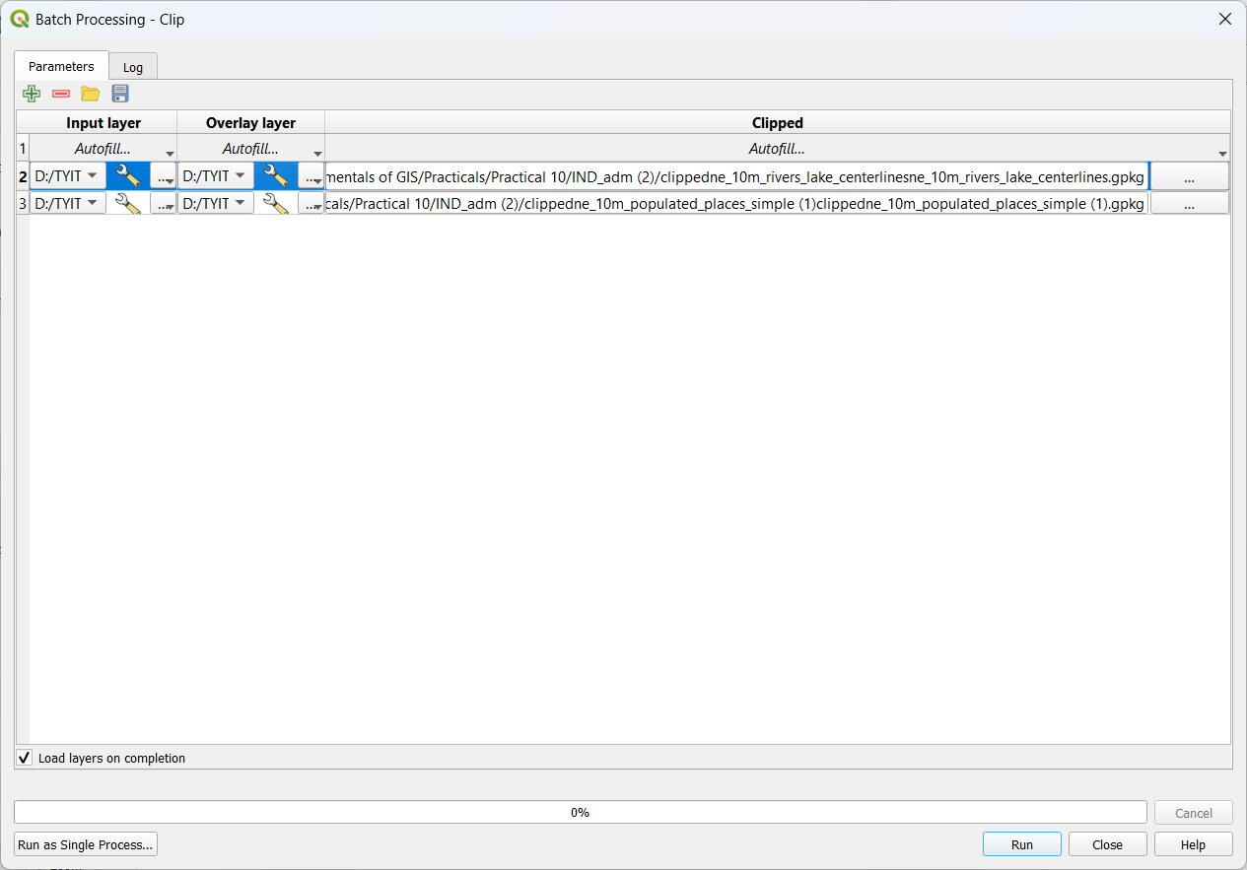

Batch processing window >

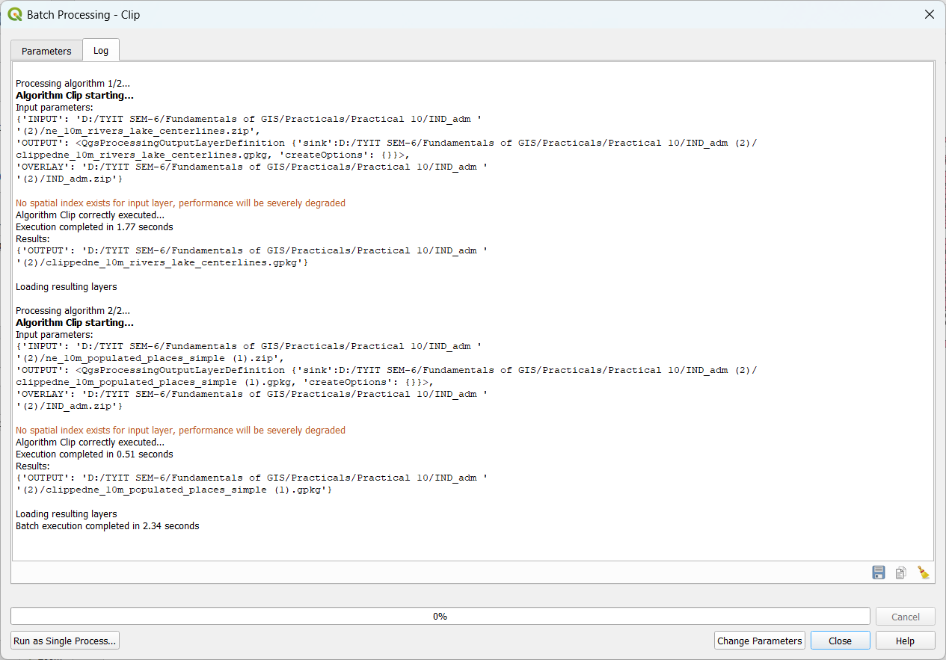

Output After clipping >

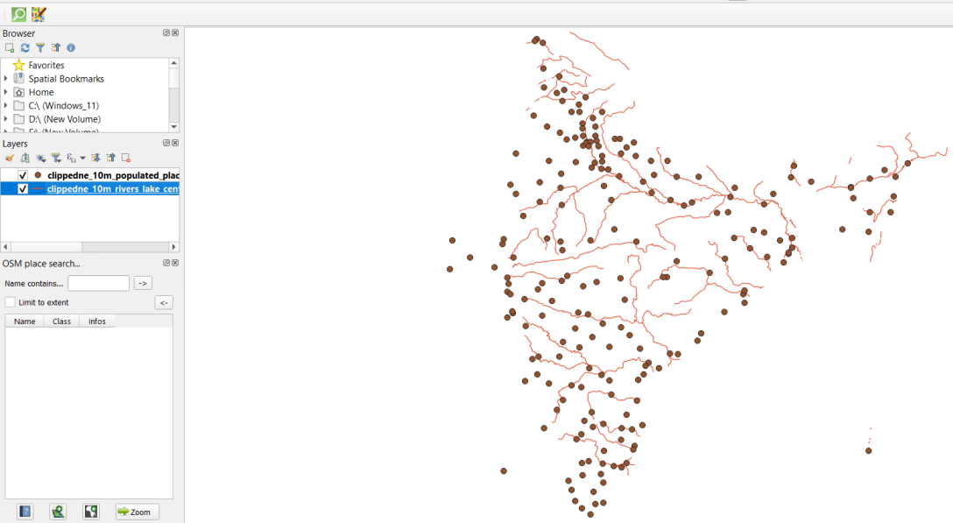

**Automating Complex Workflows using Processing Modeler:**

Processing > Graphical Modeler >

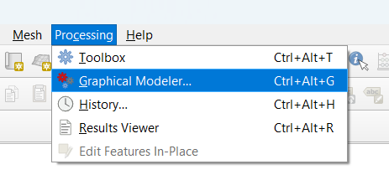

Select Raster Layer at Inputs > Give Description > Ok

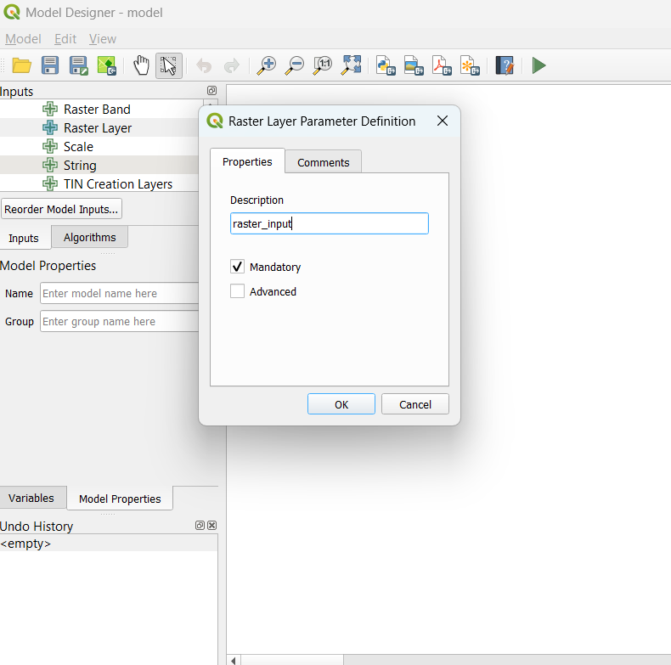

Output after adding raster input >

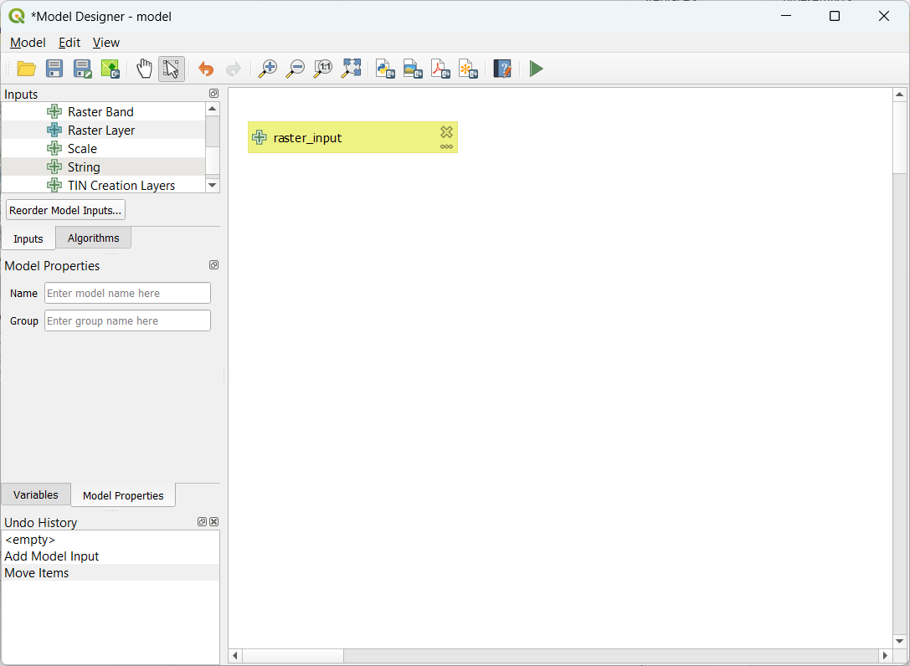

At Algorithms Select Majority/Minority Filter >select raster_input for model input > ok >

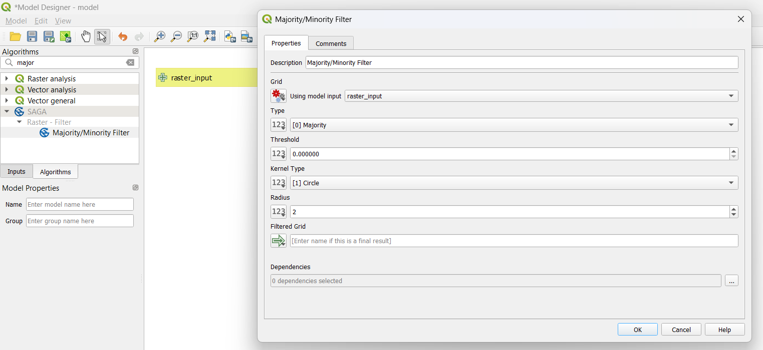

At Algorithms Select Polygonize > select “Majority/Minority Filter” for input layer > Band number : 1 > Name of Field to create : DN > ok >

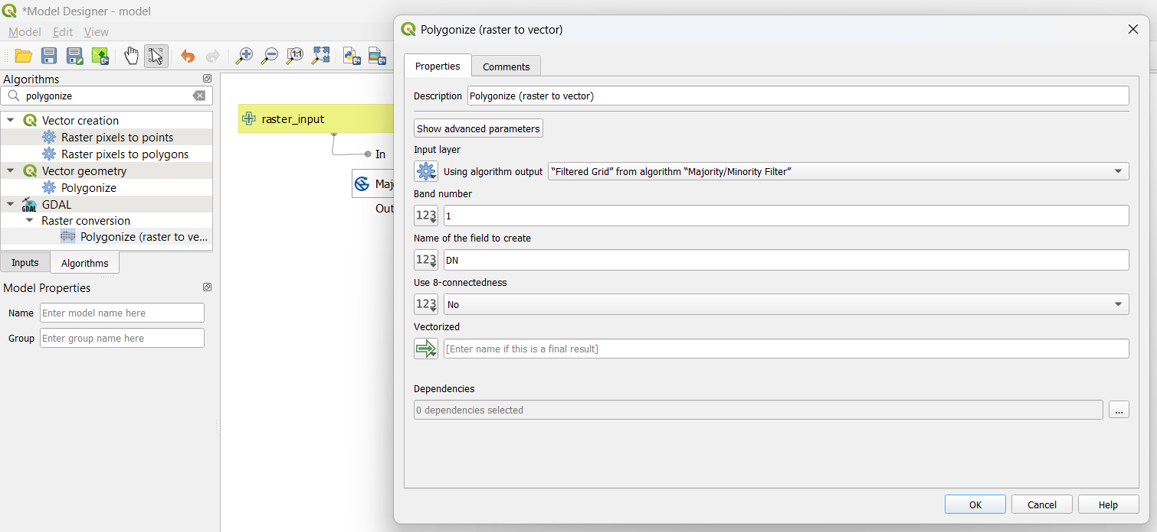

At Algorithms Select Extract by attribute > select “Polygonize” for input layer > selection attribute : DN > Operator : = > Value : 12 > ok >

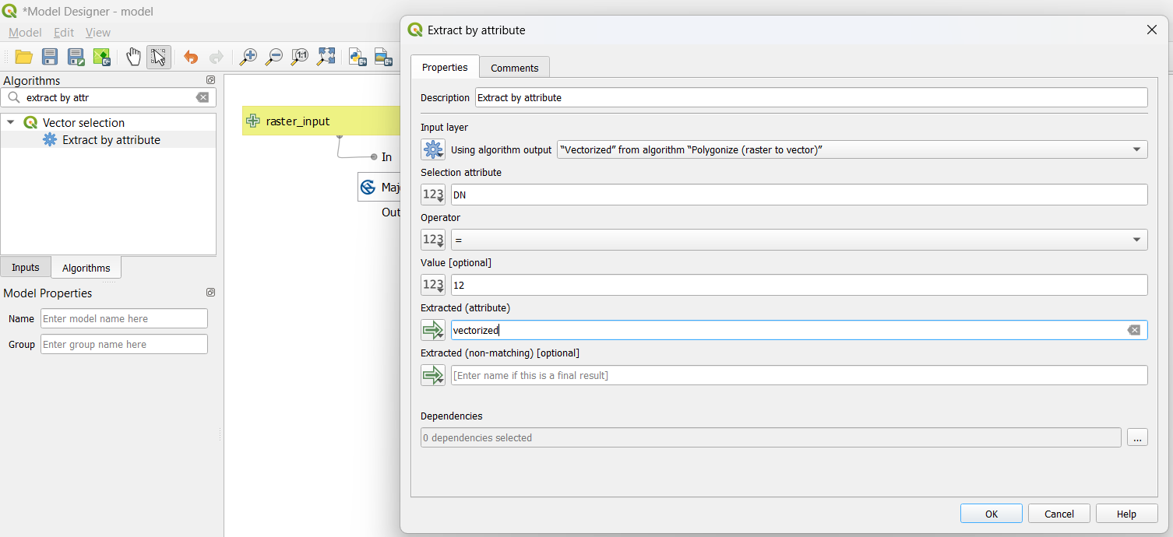

Output after adding Input and algorithms in model >

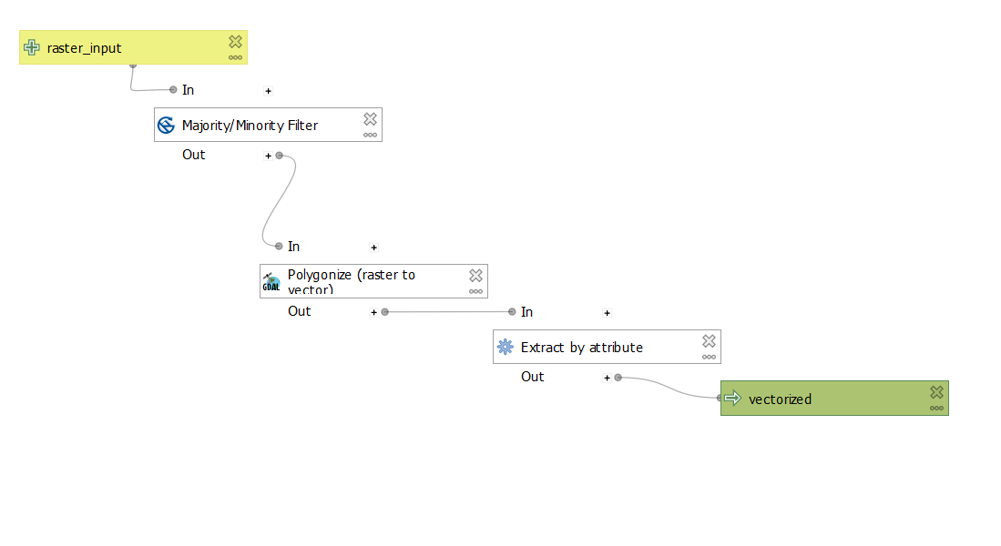

Save the model at default location >

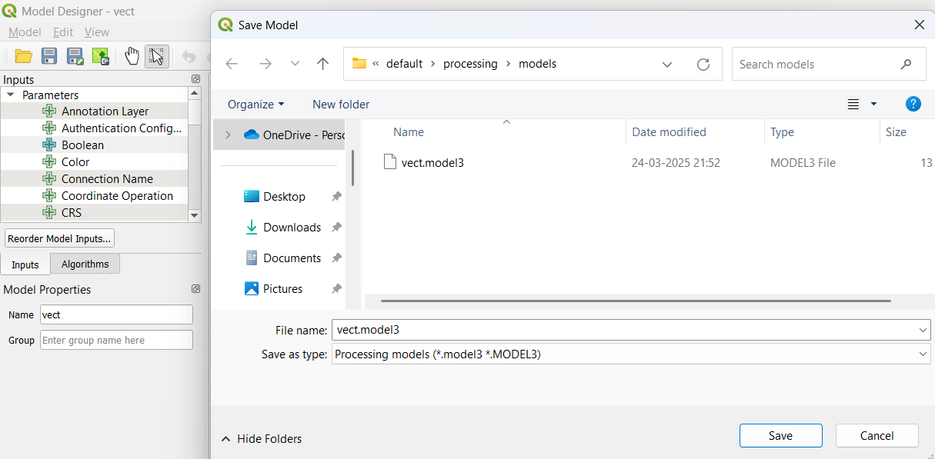

Layer > Add Layer > Add Raster Layer >

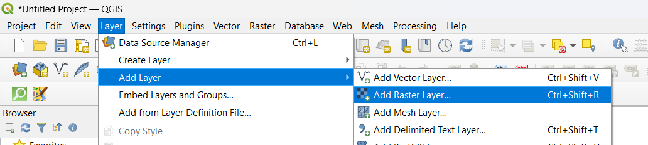

Select “LC_hd_global_2001.tif.gz” >

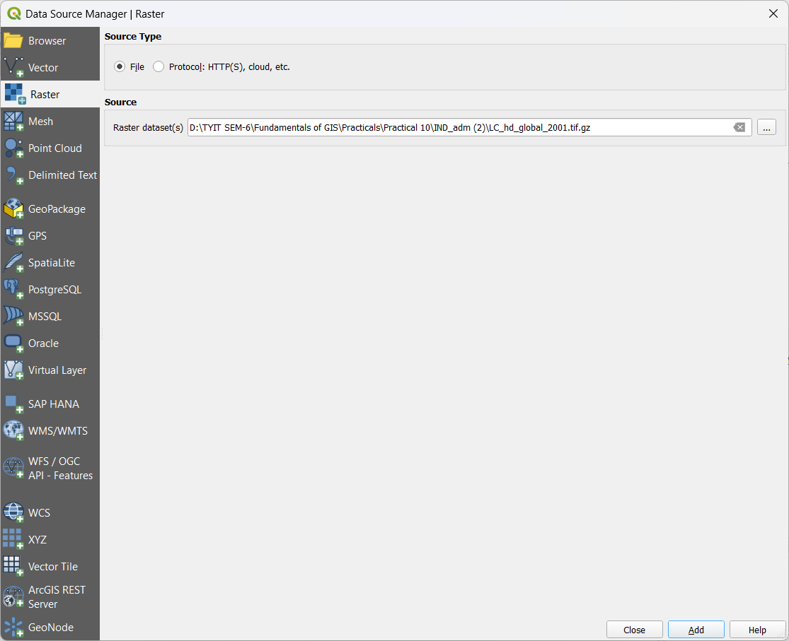

Output after adding Vector LC_hd_global_2001.tif.gz >

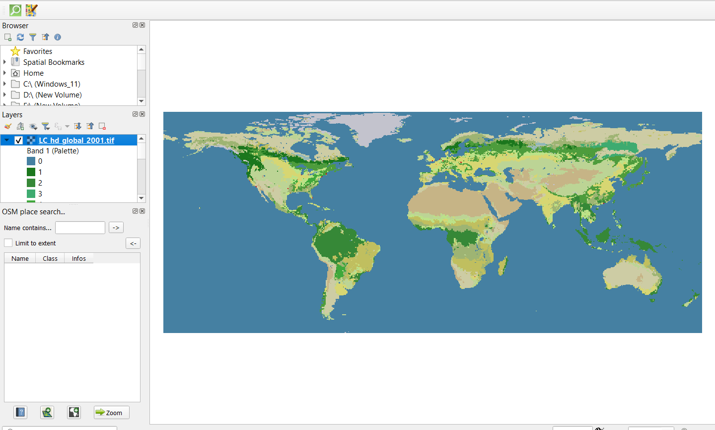

Select “LC_hd_global_2012.tif.gz” >

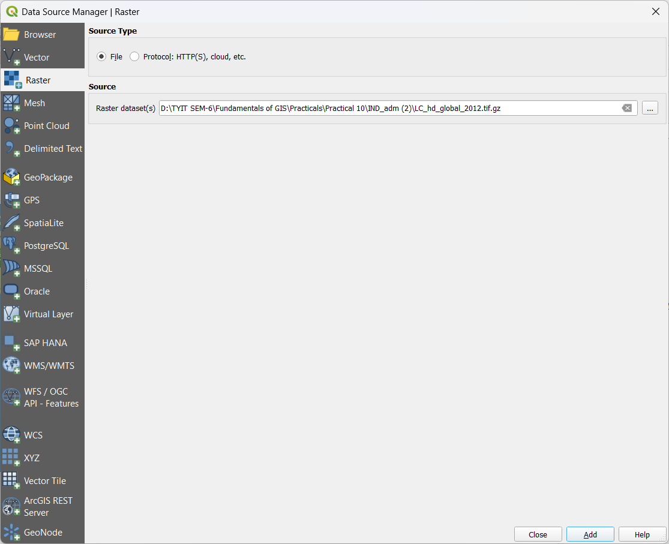

Output after adding “LC_hd_global_2012.tif.gz” >

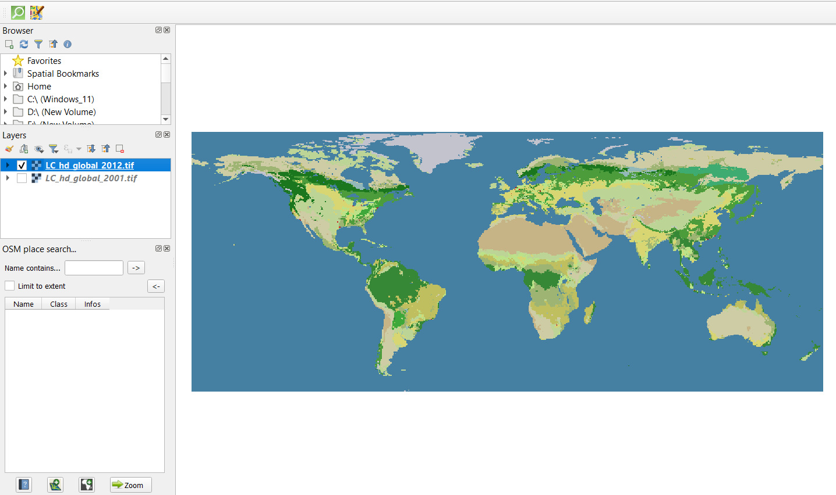

At Processing Toolbox > Clcik vect model > Set raster_input:LC_hd_global_2001.tif > vectorized : model1.gpkg > Run >

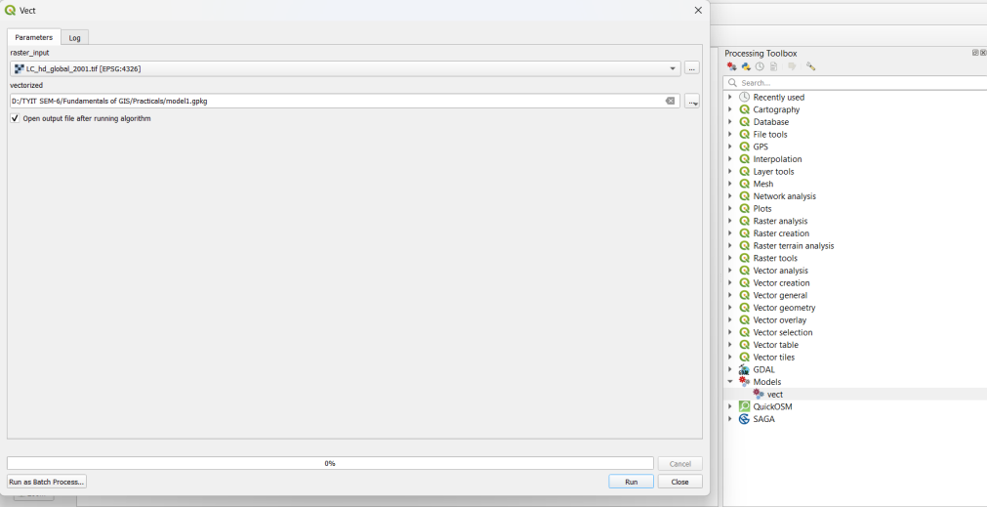

At Processing Toolbox > Clcik vect model > Set raster_input:LC_hd_global_2012.tif > vectorized : model2.gpkg > Run >

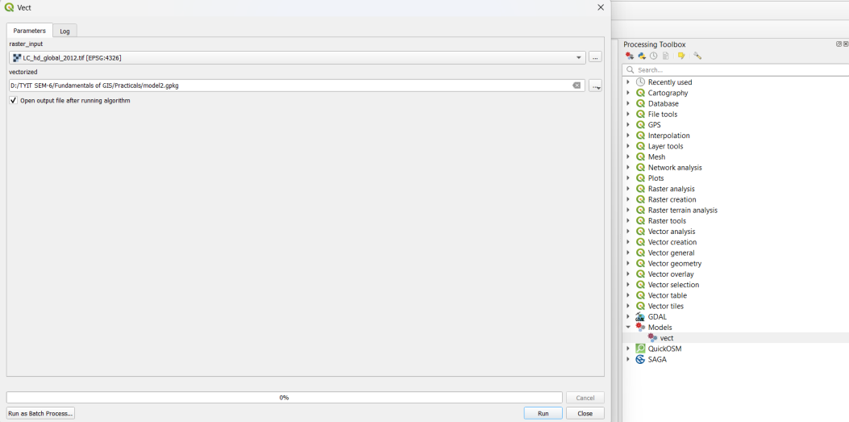

Output after adding model1 and model 2 >

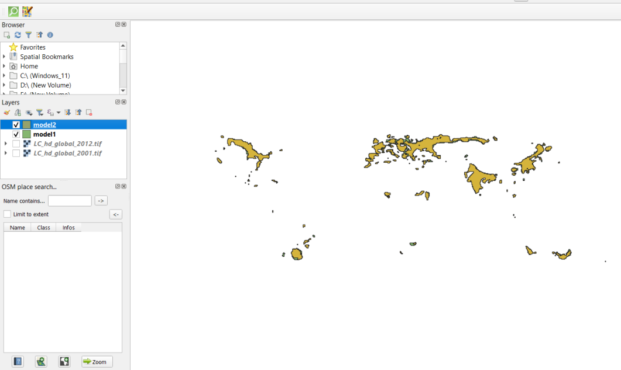

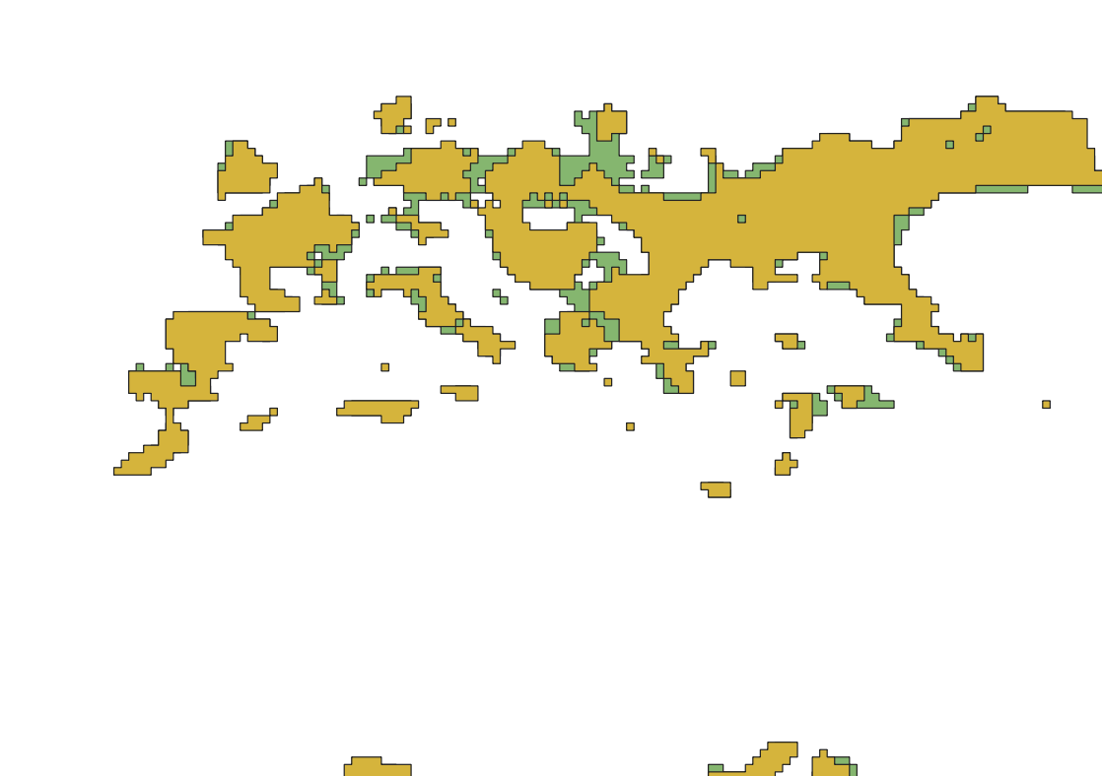

**Automating Map Creation with Print Composer Atlas:**

Add Layer > new vector layer > **HI_Wetlands.shp**

Add Layer > new vector layer > **country10.shp**

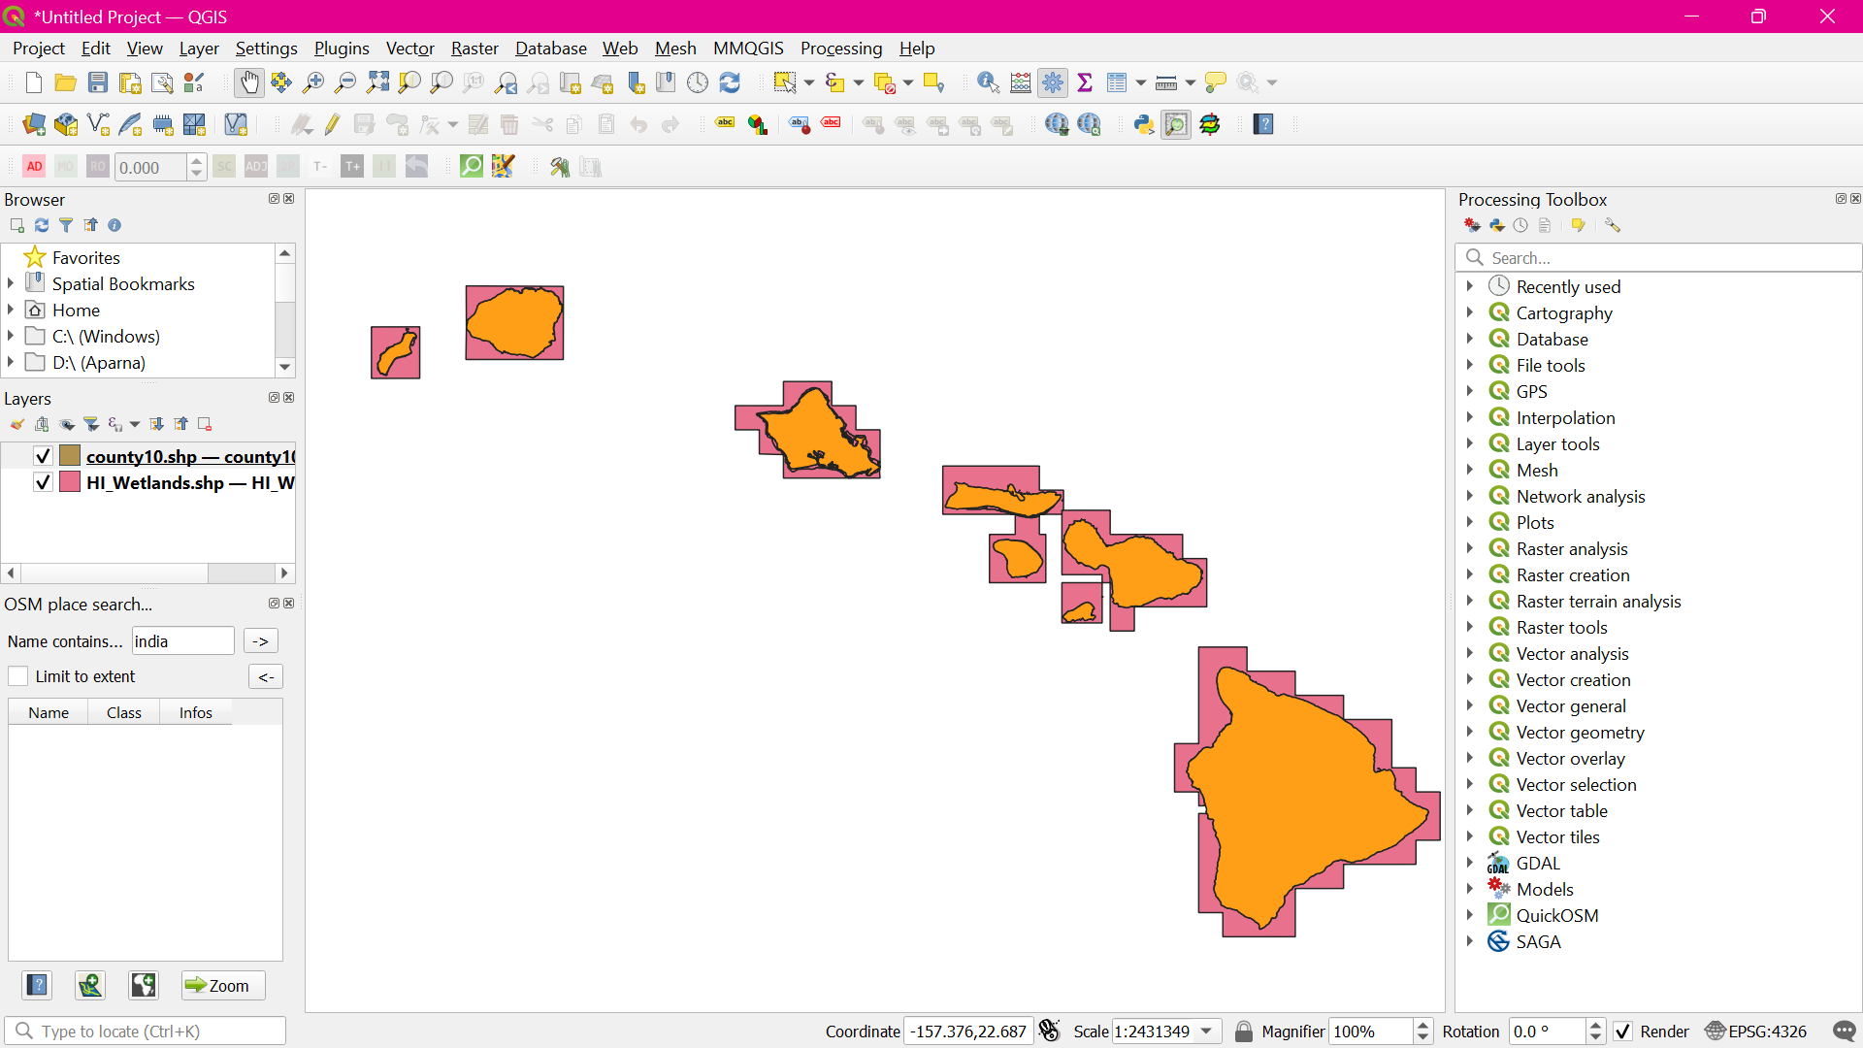

Project > New Print Layout

Add Item > Add Map

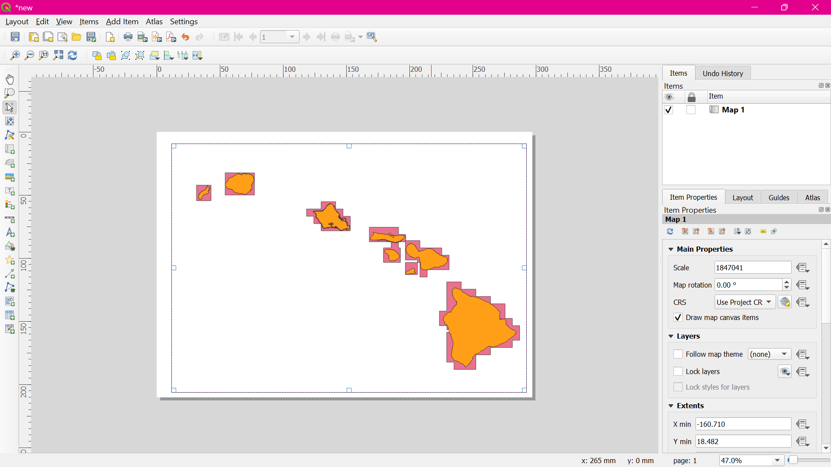

Switch to the Atlas tab. Check the **Generate an atlas box**. Select the **county10 as the Coverage layer**. An also **check the Hidden coverage layer box**

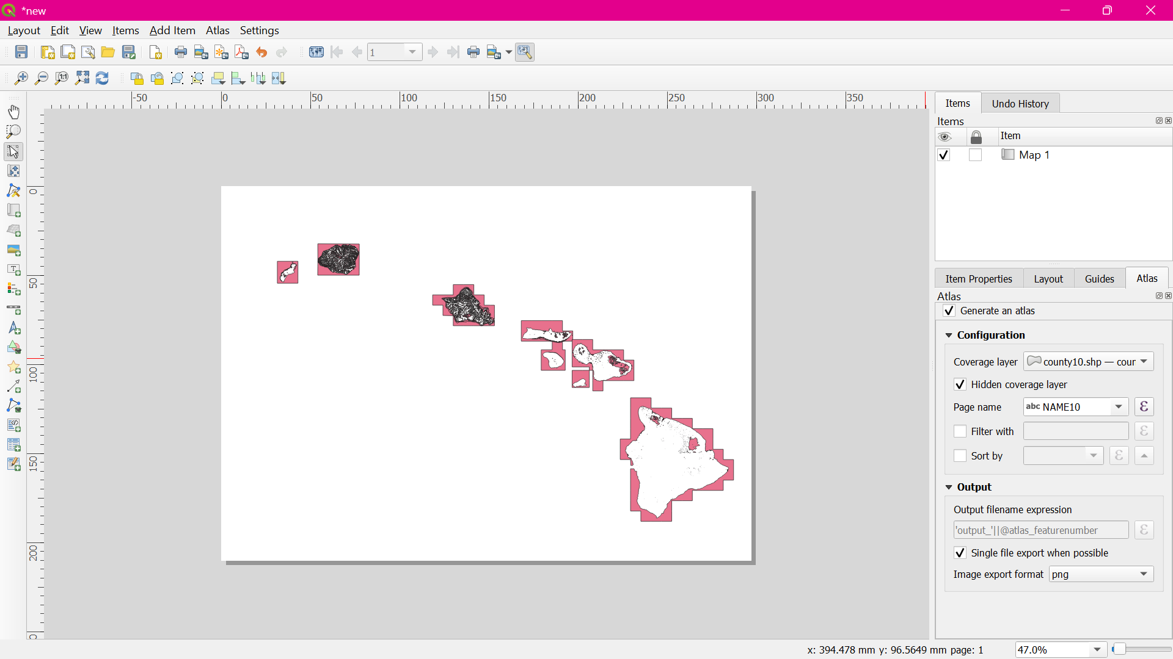

1. Go to Atlas > Preview Atlas.
2. Go to Add Item > Add Label.
3. Under the Item properties tab, click **Insert an expression**... button.
4. Add an expression like below and click OK**. concat('County of ', "NAME10")**

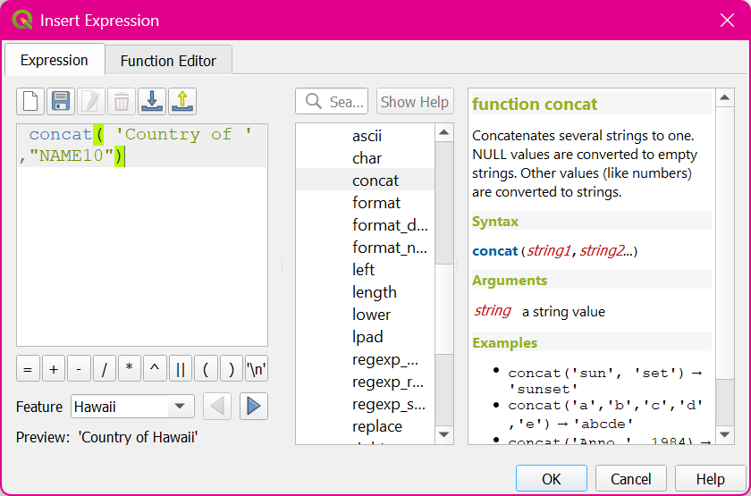

Adjust the font size to your liking.  
 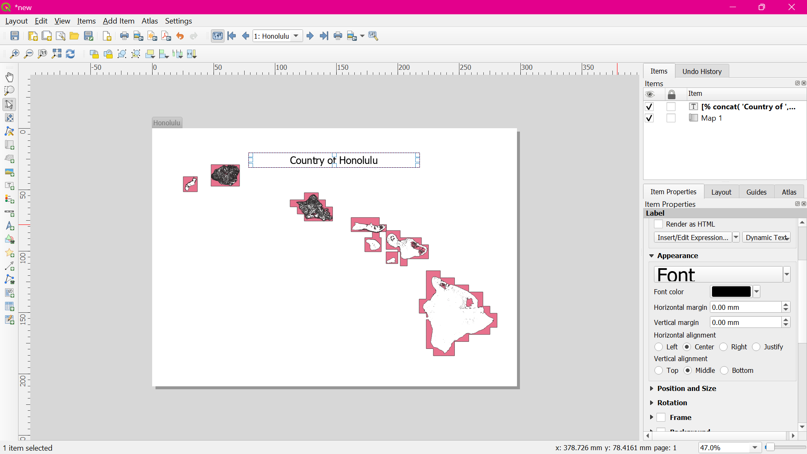

**Add another label and enter Wetlands Map** under the Main properties. Since there is no expression here, this text will remain the same on all maps.

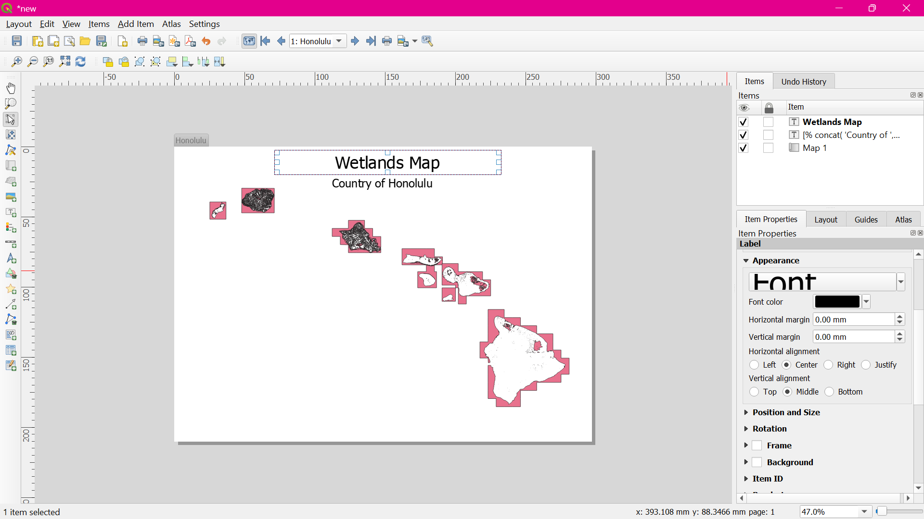

Switch to the main QGIS window. Right-click the county10 layer and select Properties.

In the Style tab, select **the Inverted polygons renderer**. Select **white as the fill color** and click OK.

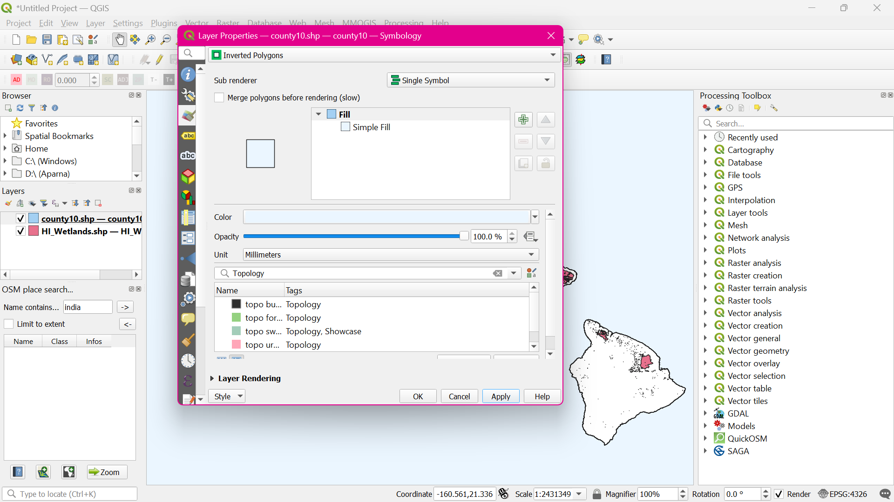

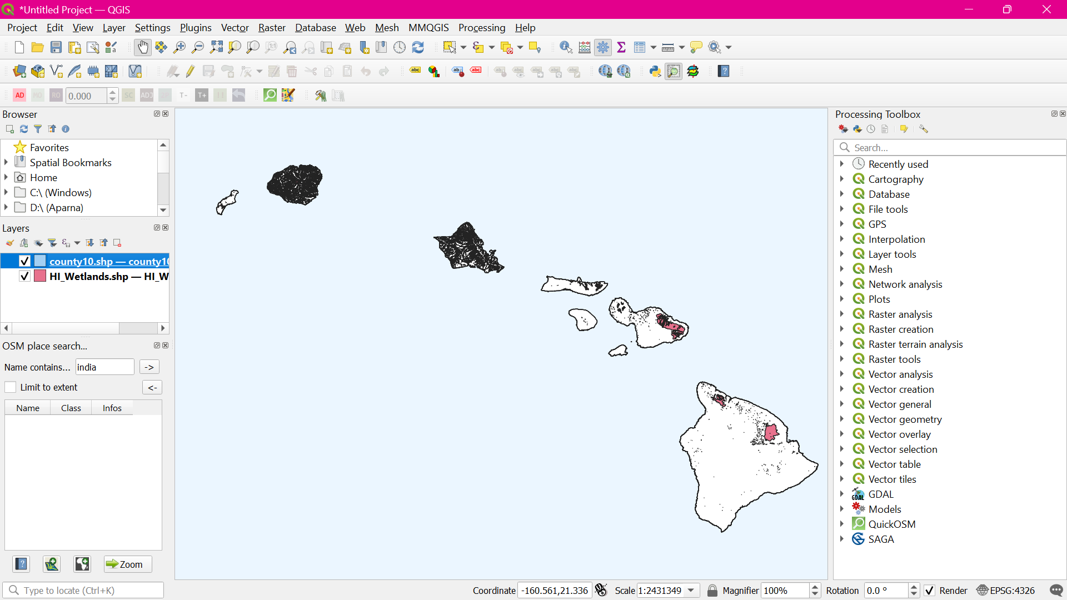

Switch to the Print Composer window. If we want the effect of the inverted polygons to show, we need to **uncheck the Hidden coverage layer box under Atlas generation.**

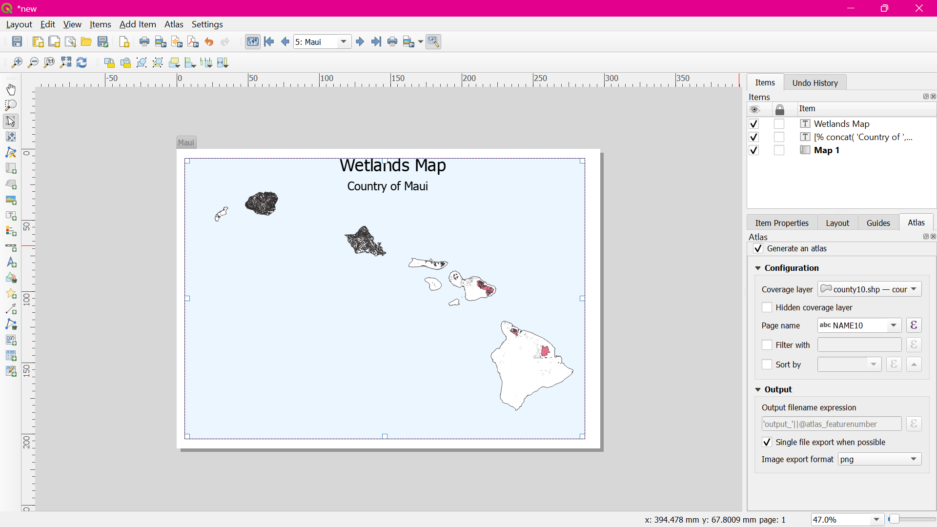

1. Switch to **the main QGIS window**. Right-click the county10 layer and select Properties.
2. In the Style tab, **select Rule-based renderer as the Sub renderer**. Double-click the area under Rule.
3. In the **Expression string builder**, expand the Atlas group of functions.
4. Enter the expression as : **$id=$atlas_featureid**

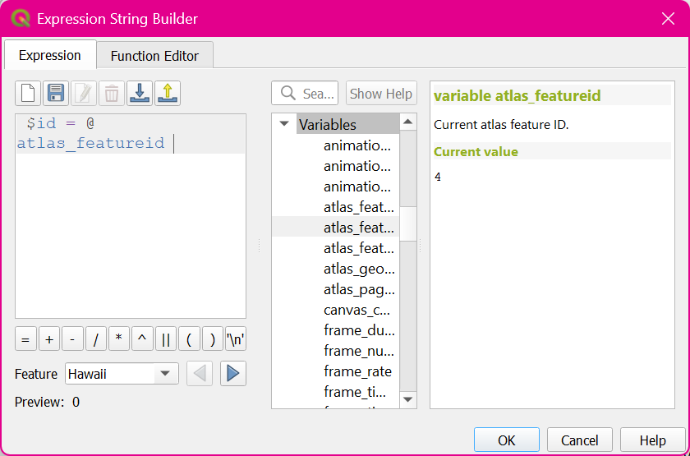

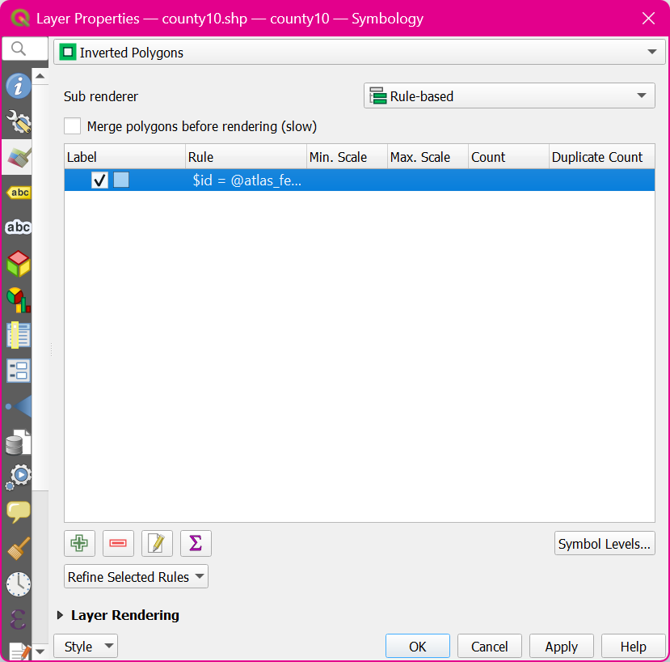

Back in the Print Composer window, click the Update preview button under Item properties tab to see the changes

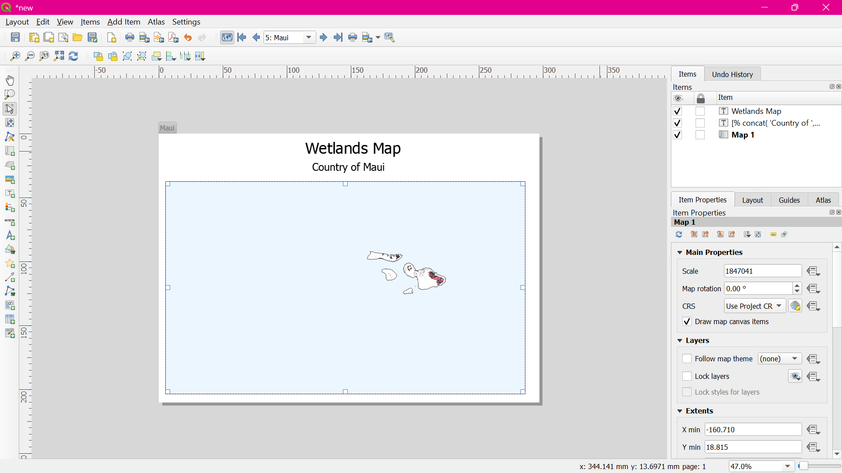

Go to Add Item > Add Label and select the area on the map. Click **Insert an expression button.**

Enter the expression as: **concat('Created on: ', to_date($now))**

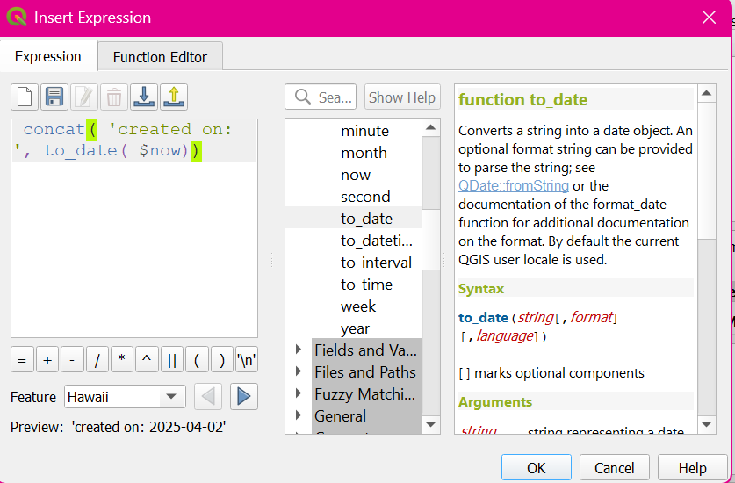

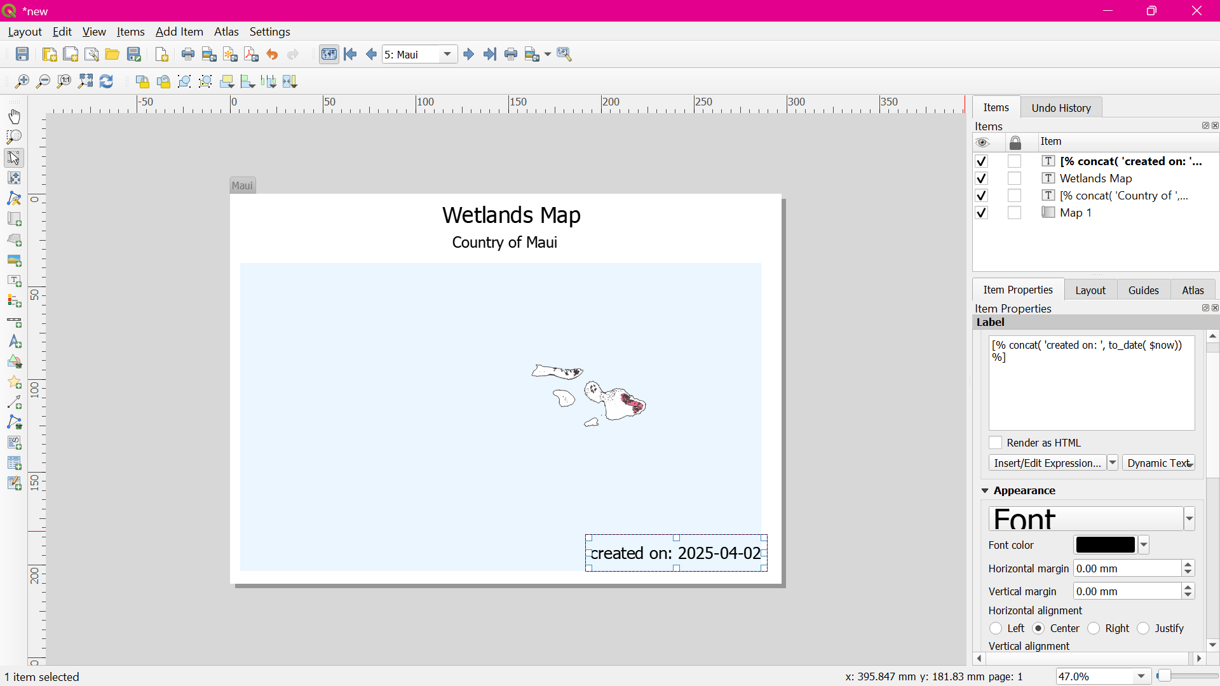

Once you are satisfied with the map layout, go to Atlas > **Export Atlas as Images**.

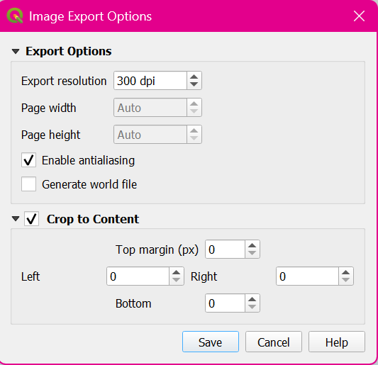

Here are the map images for reference.

